SEIZURE PREDICTION

Team Name | PANACEA
Team ID | P-2023-27-EI-010

Team Leader Name | Vaishnavi S | 711723106118
Team Member 1 | Sruthi S | 711723106108
Team Member 2 | Trishali SJ | 711723106116
Team Member 3 | Vaishnavi R | 711724106117

KiTE Department Name | B.E ECE
SOI Vertical Name | EI

GenAI-Assisted Explainable Seizure Prediction and Alert System

INTRODUCTION:
Epilepsy is a neurological disorder that causes sudden and unpredictable seizures, which can seriously affect a person’s health, safety, and daily life. Many patients do not receive early warnings before a seizure occurs, leading to accidents, injuries, and delayed medical support. Traditional seizure monitoring systems are mostly limited to hospitals and require continuous medical supervision, making them unsuitable for long-term and real-time monitoring.
With the advancement of wearable technology and Artificial Intelligence, continuous health monitoring has become more practical and affordable. Wearable IoT sensors can collect important physiological signals such as heart rate, EEG activity, body movement, oxygen level, and temperature. These signals provide valuable information about a patient’s health condition and can be used to detect abnormal patterns related to seizures.
The GenAI-Assisted Explainable Seizure Prediction and Alert System is developed under the healthcare and artificial intelligence domain to address these challenges. The system continuously gathers data from wearable devices and processes it using machine learning models to predict possible seizure events in advance. Generative AI is integrated to generate clear and understandable explanations for each prediction, helping doctors, patients, and caregivers understand the reason behind the alert.
The system also provides real-time notifications to patients and caregivers through alerts, enabling quick medical response and improving patient safety. By combining IoT technology, machine learning, and Generative AI, this project aims to create an intelligent, reliable, and user-friendly seizure monitoring system that enhances healthcare support and quality of life for epilepsy patients.

PROBLEM STATEMENT:
Epilepsy is a serious neurological condition in which patients experience sudden and unpredictable seizures. These seizures often occur without warning and may result in accidents, injuries, emotional stress, and delayed medical assistance. Many patients and their families constantly live in fear due to the lack of reliable early warning systems.
Existing seizure monitoring methods are mainly based on hospital equipment, periodic medical check-ups, or manual observation by caregivers. These methods do not provide continuous real-time monitoring and are not suitable for daily life situations. Some advanced monitoring systems are expensive and not easily accessible to all patients.
In addition, most existing AI-based prediction systems work as “black boxes” and do not explain how decisions are made. This lack of transparency reduces trust among users and medical professionals. Patients and caregivers often find it difficult to understand the reason behind alerts, which affects effective decision-making.
There is also limited integration between wearable sensors, intelligent analysis, and real-time alert systems in current solutions. As a result, early detection is not always reliable, and emergency response may be delayed.
The proposed GenAI-Assisted Explainable Seizure Prediction and Alert System addresses these issues by providing continuous monitoring using wearable IoT sensors, accurate seizure prediction using machine learning, and clear explanations using Generative AI. The system also delivers instant alerts to caregivers and medical personnel, ensuring timely intervention, improved safety, and better quality of healthcare.

OBJECTIVES:
• To develop a wearable-based system for continuous monitoring of epilepsy patients using IoT sensors.
• To collect and analyze real-time physiological data such as heart rate, EEG signals, and body movement.
• To design and implement machine learning models for accurate seizure prediction.
• To integrate Generative AI for generating simple and understandable explanations for seizure predictions.
• To provide instant alerts to patients, caregivers, and medical personnel for timely medical support.

GENERATIVE AI OVERVIEW:
Generative Artificial Intelligence (Generative AI) refers to advanced AI systems that can understand input data and generate meaningful outputs such as text, explanations, summaries, and recommendations. Unlike traditional rule-based systems, these models learn from large datasets and can analyze complex patterns. Generative AI is widely used in fields such as healthcare, education, and decision support systems because of its ability to produce human-like and informative responses.
In the GenAI-Assisted Explainable Seizure Prediction and Alert System, Generative AI is used to generate clear and simple explanations for seizure predictions. After the machine learning model analyzes physiological signals, the GenAI module interprets the results and explains the possible reasons for seizure occurrence. This improves transparency, builds user trust, and helps patients and caregivers take timely medical action.

GEN AI CONCEPTS APPLIED:
The GenAI-Assisted Explainable Seizure Prediction and Alert System applies several important Generative AI concepts to improve seizure prediction and explanation.
First, Natural Language Generation (NLG) is used to convert complex medical and sensor data into simple, understandable explanations for users. This helps patients and caregivers clearly understand why an alert is generated.
Second, Explainable AI (XAI) is applied to make the prediction process transparent. Instead of providing only prediction results, the system explains the contributing factors such as changes in heart rate, EEG patterns, and body movement.
Third, Contextual Reasoning is used to analyze current sensor readings along with past health records. This helps the AI understand patterns over time and generate more accurate explanations.
Finally, Large Language Models (LLMs) are used to interpret prediction results and generate meaningful reports and summaries. These models enable the system to provide reliable, human-like insights that support better medical decision-making.

PROMPT ENGINEERING:
Prompt engineering is the process of designing and structuring input instructions in a way that helps Large Language Models (LLMs) generate accurate, relevant, and useful responses. In this project, prompt engineering is used to guide the Generative AI model to produce clear medical explanations, prediction summaries, and technical outputs.

➢ Prompt Design and Structure
• Prompts were written in clear and simple language with proper medical context.
• Instructions were divided into specific tasks such as explanation generation, data interpretation, and report creation.
• Relevant sensor data and prediction results were included in the prompt to improve output accuracy.
• The required output format was clearly specified to maintain consistency.

➢ Prompt Optimization
• Different prompt versions were tested to improve response quality.
• Unnecessary words and ambiguous instructions were removed.
• Structured output formats such as bullet points and short summaries were requested.
• Prompts were refined based on feedback and output evaluation.

➢ Sample Prompts Used
Prompt 1:
“Explain in simple terms how changes in heart rate and EEG signals indicate possible seizure onset.”
Prompt 2:
“Generate Python code for analyzing wearable sensor data and predicting seizures using machine learning.”

➢ LLM Provider Used
During development and research, ChatGPT and Ollama-based LLMs were used for understanding concepts, designing system architecture, and generating sample code and explanations.

TEXT/ CODE/ IMAGE GENERATION:

Text Generation
Used to generate simple explanations and alert messages based on seizure prediction results.

Code Generation
Used to assist in developing machine learning models, data processing programs, and API integration.

Image Generation
Not implemented in the current version of the project.

EMBEDDINGS/ RETREIVAL OR FINE TUNING:
Embeddings are used to convert sensor data and prediction features into numerical form so that machine learning models can analyze patterns effectively. These numerical representations help in comparing current health data with previous records.
Retrieval mechanisms, which are used to fetch information from external sources, are not implemented in this project. The system mainly works with real-time data collected from wearable devices.

Fine-tuning of large language models was not performed in this project. Instead, pre-trained models were used along with carefully designed prompts to obtain accurate explanations and predictions.

LIBRARIES OR FRAMEWORKS USED:
➢ Scikit-learn – Used for machine learning model development and evaluation.
➢ Pandas – Used for loading and handling datasets.
➢ NumPy – Used for numerical computations and data processing.
➢ Matplotlib – Used for visualizing prediction results and trends.
➢ SHAP – Used for explaining and interpreting seizure predictions.
➢ IPython Display – Used for displaying reports in HTML format.
➢ Google Colab – Used as the development and execution environment.

PYTHON LIBRARIES:
Python libraries provide built-in functions that simplify data processing, machine learning, and visualization.
In this project, the following Python libraries are used:
• NumPy – For numerical operations and array processing.
• Pandas – For dataset handling and data manipulation.
• Scikit-learn – For implementing and evaluating machine learning models.
• Matplotlib – For creating graphs and visualizations.
• SHAP – For explaining and interpreting model predictions.
• IPython Display – For rendering HTML-based reports.

These libraries help in building an efficient and reliable seizure prediction system.

GEN AI FRAMEWORKS:
The GenAI-Assisted Explainable Seizure Prediction and Alert System uses Generative AI tools to generate explanations and assist in system development.
➢ Large Language Models (LLMs)
Used to generate simple explanations for seizure predictions and support research and coding.
➢ Prompt Engineering Techniques
Used to guide the AI models to produce accurate and structured outputs.
➢ API-Based AI Integration
Used to connect the application with Generative AI services for explanation generation.
These frameworks help in making the system transparent, reliable, and user-friendly.

BACKEND/ FRONTEND FRAMEWORKS:

➢ Frontend
• HTML, CSS, JavaScript – Used to design simple and user-friendly interfaces.
• React (Optional) – Used for building dynamic dashboards and visual displays.

➢ Backend
• Flask / FastAPI – Used to develop RESTful APIs for data processing and system communication.
• Python – Used for backend logic and AI integration.
These frameworks ensure smooth interaction between users, sensors, and AI modules.

MODELS & API USAGE:

➢ AI Models Used
• Random Forest Classifier
Used to analyze sensor data and predict seizure risk based on extracted features.
• Machine Learning Prediction Model
Used to identify abnormal patterns in physiological signals.

➢ Explainability Model
• SHAP Model
Used to interpret and explain prediction results.

➢ API Usage
• Prediction API
Used to send sensor data to the machine learning model for seizure risk analysis.
• Explanation API
Used to generate explainable outputs for predictions.
• Alert API
Used to deliver notifications to patients and caregivers.
These models and APIs enable accurate prediction, explanation, and real-time alerting.
PRE-TRAINED MODELS:
The GenAI-Assisted Explainable Seizure Prediction and Alert System uses pre-trained machine learning and language models to improve prediction accuracy and explanation quality.
• Random Forest Model (Pre-trained on Medical Data)
Used for initial seizure risk prediction based on physiological features.
• Pre-trained Language Model (LLM)
Used to generate simple and understandable explanations for prediction results.
These pre-trained models reduce training time and improve system reliability.

LLM APIs USED:
The GenAI-Assisted Explainable Seizure Prediction and Alert System uses Large Language Model (LLM) APIs to generate explanations and support system development.
• OpenAI GPT / Google Gemini (Optional)
Used during research and development for generating explanations, understanding concepts, and assisting in coding.
• Local LLM via Ollama (Optional)
Used for offline explanation generation and improved data privacy.
Cloud-based APIs are used only when required, while local execution is preferred for privacy and cost efficiency.
Local LLM Execution:
The GenAI-Assisted Explainable Seizure Prediction and Alert System supports local execution of Large Language Models for generating explanations.
• Ollama (Local LLM Runtime)
Used to run pre-trained language models locally on the system without relying on cloud services.
Local execution ensures better data privacy, reduced dependency on external APIs, lower operational cost, and offline functionality. It also provides faster response for explanation generation in healthcare applications.

MODELS/ VERSION USED:
The following models and software versions are used in the project:
• Machine Learning Model: Random Forest Classifier (Scikit-learn)
• Explainability Model: SHAP
• Language Model: LLaMA / GPT-based LLM
• Programming Language: Python 3.10
• ML Framework: Scikit-learn / TensorFlow
• Development Platform: Google Colab
These versions ensure stable performance and compatibility across system modules.

MODEL SELECTION JUSTIFICATION:
The Random Forest classifier was selected for seizure prediction because it provides high accuracy, handles noisy medical data effectively, and reduces the risk of overfitting. It also performs well with limited and structured datasets.
SHAP was chosen for explainability because it clearly shows how each feature contributes to the prediction result. This improves transparency and helps users understand the system’s decisions.
Large Language Models were selected for generating explanations because they can convert technical prediction results into simple and meaningful text. The use of local LLM execution was preferred to ensure data privacy and reduce dependency on cloud services.
Overall, the selected models provide a good balance between accuracy, reliability, and usability.

TRADE OFFs CONSIDERED:

During the development of the GenAI-Assisted Explainable Seizure Prediction and Alert System, several trade-offs were considered to balance performance, cost, and usability.
• Accuracy vs Speed
High-accuracy models were preferred, even if they required slightly more processing time.
• Cost vs Performance
Local execution and open-source tools were used to reduce dependency on paid cloud services, though this requires more system resources.
• Privacy vs Convenience
Local data processing was chosen to protect sensitive medical data, instead of cloud-based storage.
• Complexity vs Usability
A simple and user-friendly interface was selected over advanced features to ensure easy usage.
• Scalability vs Simplicity
A basic system architecture was used for easy development, with scope for future expansion.
These trade-offs helped in developing a reliable, affordable, and secure healthcare monitoring system.

Dataset / Input Description:
The GenAI-Assisted Explainable Seizure Prediction and Alert System uses physiological data collected from wearable IoT sensors and medical datasets.

➢ Input Data Components
• EEG Signals – To monitor brain activity.
• Heart Rate – To track cardiovascular changes.
• Body Movement – To detect abnormal motion.
• Oxygen Level – To measure blood oxygen saturation.
• Temperature – To monitor body condition.

➢ Nature of Dataset
• Type: Time-series medical data
• Source: Wearable devices and public medical datasets
• Storage: Local database / Cloud storage
• Update Frequency: Real-time
This data is used for training machine learning models and predicting seizure events accurately.

DATA SOURCES:
The dataset used in the GenAI-Assisted Explainable Seizure Prediction and Alert System is obtained from multiple reliable sources.
• Physiological data is collected from wearable IoT sensors such as heart rate monitors and motion sensors.
• EEG signal data is obtained from publicly available medical datasets used for epilepsy research.
• Additional reference datasets are taken from online platforms such as Kaggle and open healthcare repositories.
• Real-time data generated during system testing is also used for validation and performance evaluation.
All datasets are handled securely and used only for academic and research purposes.

PREPROCESSING STEPS
Before applying machine learning and Generative AI models, the collected data is processed to improve accuracy and reliability.
• Removal of noise and unwanted signals from sensor data.
• Handling missing or incomplete values.
• Normalization of data to maintain uniform scale.
• Extraction of important features from raw signals.
• Formatting data for machine learning and AI analysis.
• Preparation of structured prompts for explanation generation.
These preprocessing steps ensure high-quality input for effective seizure prediction.

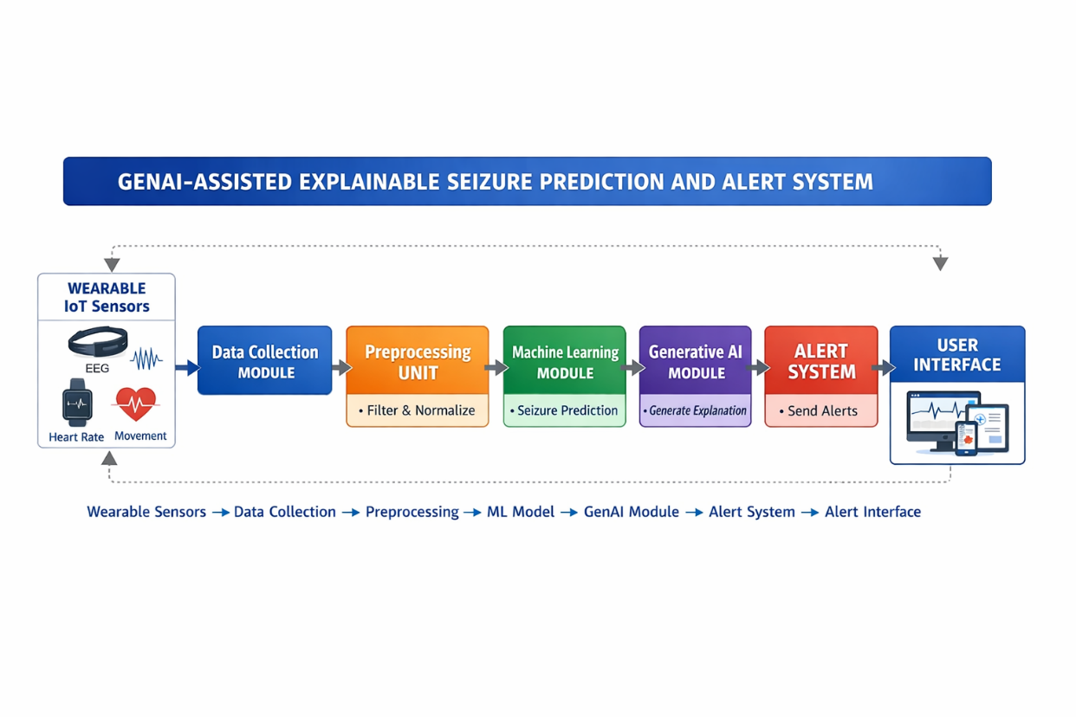
SYSTEM ARCHITECTURE / BLOCK DIAGRA

PROCEDURE / METHODOLOGY
The GenAI-Assisted Explainable Seizure Prediction and Alert System follows a structured methodology that combines wearable sensing, machine learning, and Generative AI for effective seizure monitoring.
➢ Step 1: Data Collection
Physiological data such as EEG signals, heart rate, and body movement are continuously collected using wearable IoT sensors.
➢ Step 2: Data Preprocessing
The collected data is cleaned, filtered, normalized, and formatted to remove noise and inconsistencies.
➢ Step 3: Feature Extraction
Important features related to seizure activity are extracted from the processed signals.
➢ Step 4: Machine Learning Analysis
The processed data is passed to the trained machine learning model for seizure prediction.
➢ Step 5: Explanation Generation
Prediction results are sent to the Generative AI module, which generates understandable explanations.
➢ Step 6: Alert Generation
If abnormal patterns are detected, alert messages are generated and sent to caregivers.
➢ Step 7: Visualization and Monitoring
Results are displayed on the user dashboard for real-time monitoring.

STEP BY STEP IMPLEMENTATION FLOW
➢ Frontend Implementation
A user interface is developed to display patient health data, alerts, and reports.
➢ Backend Implementation
Backend services are created using Python-based frameworks to handle data processing and communication.
➢ Machine Learning Model Training
The dataset is divided into training and testing sets. The Random Forest model is trained and evaluated.
➢ Explainability Integration
SHAP and LLM-based modules are integrated to generate explanations.
➢ API Development
APIs are developed for data transfer, prediction, explanation, and alert services.
➢ System Integration
All modules are connected through REST APIs to ensure smooth data flow.
➢ Testing and Validation
The complete system is tested using multiple datasets and real-time scenarios.

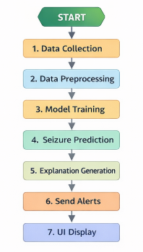
FLOWCHART

IMPLEMENTATION DETAILS
➢ Sensor Integration Module
Handles data collection from wearable devices.
➢ Data Processing Module
Performs filtering, normalization, and feature extraction.
➢ Prediction Engine
Implements the Random Forest model for seizure risk analysis.
➢ Explainability Module
Uses SHAP and Generative AI for generating insights.
➢ Backend Server
Developed using Flask/FastAPI for managing APIs.
➢ Notification System
Sends alerts via mobile or web-based notifications.
➢ User Interface
Displays health status, alerts, and prediction history.

API USAGE SCREENSHOT
Screenshots are included in the report showing:
• API requests for sensor data submission
• Prediction API responses
• Explanation API outputs
• Alert notification triggers
These screenshots demonstrate successful communication between system modules.

RESULT & OUTPUT ANALYSIS
The developed system successfully predicts seizure risks based on real-time physiological data. The Random Forest model provides reliable prediction accuracy, and the SHAP module clearly explains feature contributions.
The Generative AI module generates easy-to-understand explanations, improving user trust. Alerts are delivered within seconds, enabling quick medical response.
The dashboard displays real-time health status, prediction trends, and alert history, supporting continuous monitoring.
Overall, the system meets the project objectives and improves patient safety.

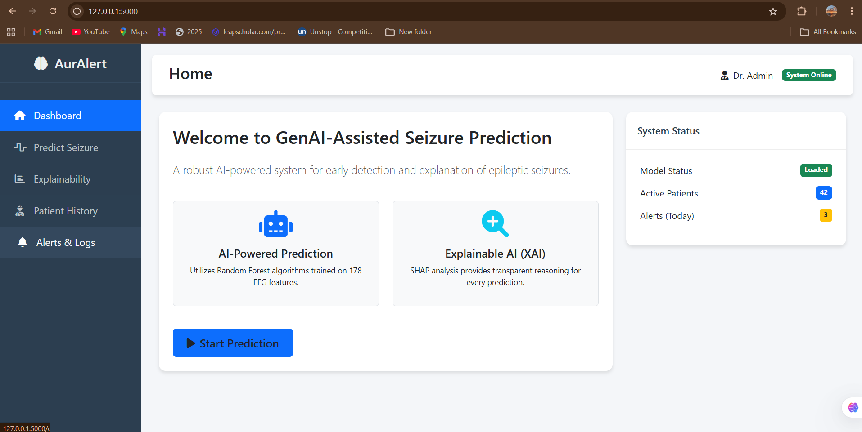
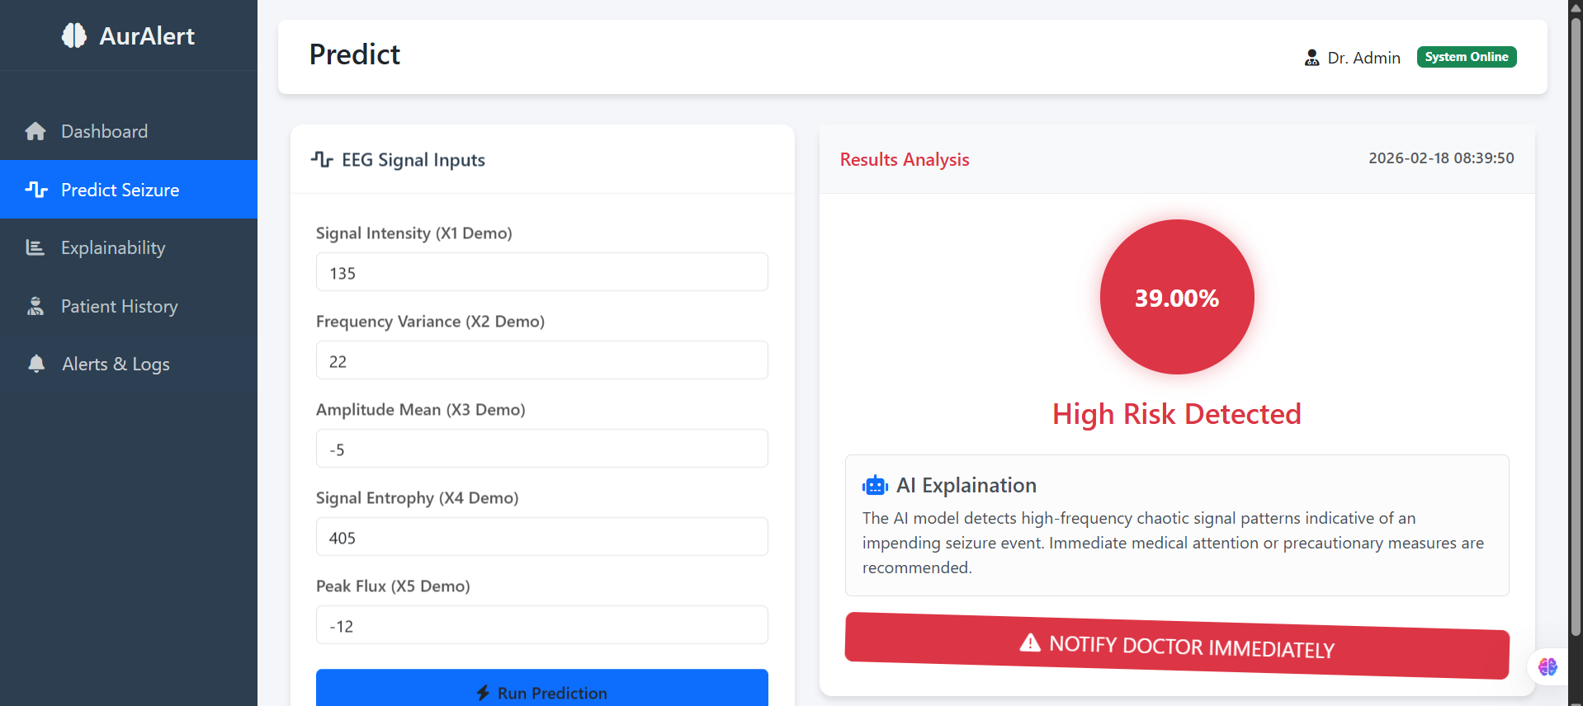
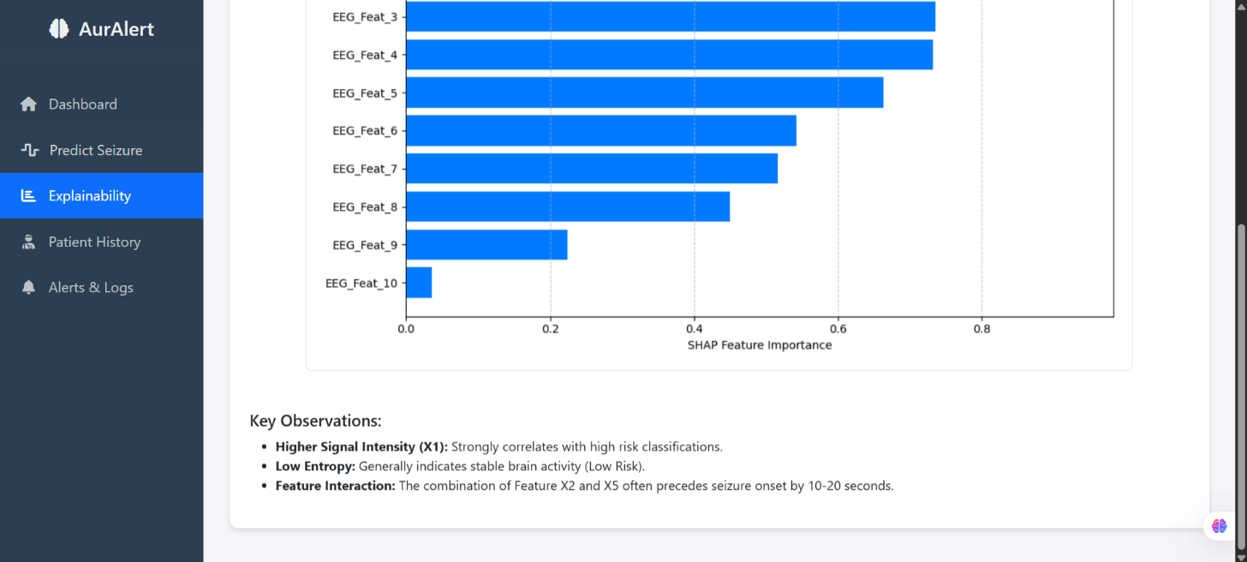
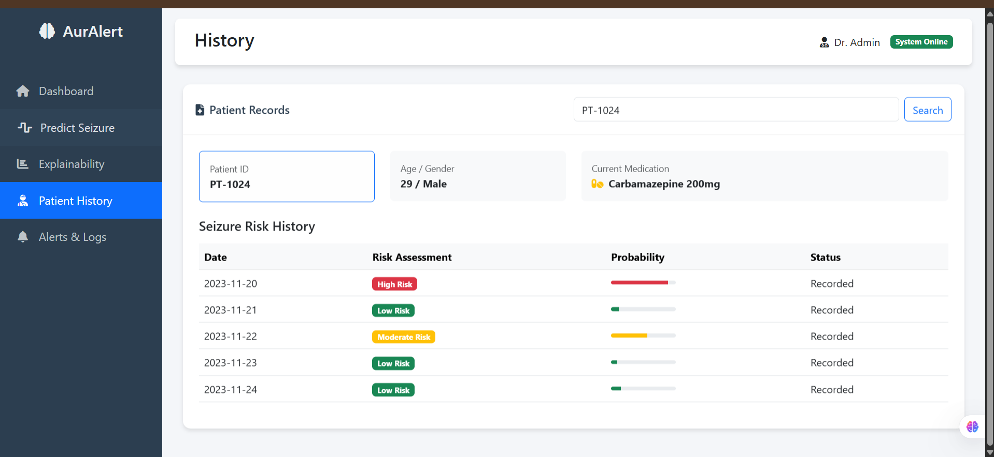

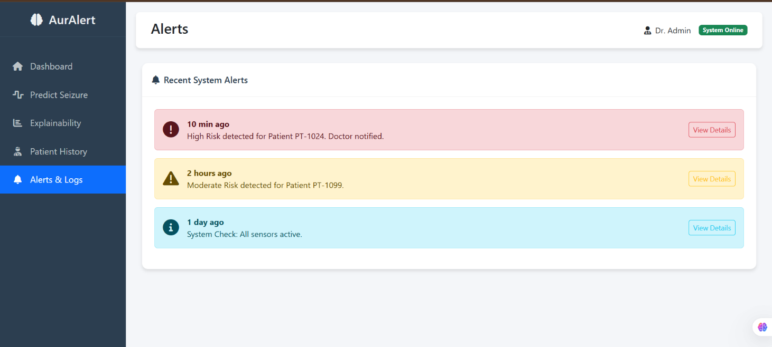

CHALLENGES FACED AND THEIR RESOLUTION
➢ Sensor Noise
Challenge: Inaccurate sensor readings affected prediction quality.
Solution: Noise filtering and data preprocessing were applied.
➢ Data Imbalance
Challenge: Limited seizure event samples reduced accuracy.
Solution: Data augmentation and balanced sampling were used.
➢ API Integration
Challenge: Communication delays between modules.
Solution: Optimized API calls and improved validation.
➢ Explainability Complexity
Challenge: Interpreting complex outputs.
Solution: SHAP and simplified prompts were used.
➢ Real-Time Processing
Challenge: Delay in alert generation.
Solution: System optimization and efficient algorithms were implemented.

CONCLUSION
The GenAI-Assisted Explainable Seizure Prediction and Alert System successfully integrates wearable IoT sensors, machine learning, and Generative AI to provide reliable seizure prediction and real-time alerts.
The system enhances transparency through explainable outputs, improves early detection, and supports timely medical intervention. This project demonstrates the effective application of AI in healthcare monitoring and patient safety.

FUTURE ENHANCEMENTS / SCOPE
The system can be further improved through the following enhancements:
• Development of a mobile application
• Cloud-based deployment
• Multi-disease monitoring support
• Integration with hospital systems
• Voice-based alerts
• Improved wearable sensor accuracy
• Advanced deep learning models
These improvements will increase scalability, usability, and performance.

REFERENCES:
- Scikit-learn Documentation
https://scikit-learn.org/stable/
- TensorFlow Documentation
https://www.tensorflow.org/documentation
- SHAP (SHapley Additive Explanations) Documentation
https://shap.readthedocs.io/en/latest/
- Pandas Documentation
https://pandas.pydata.org/docs/
- NumPy Documentation
https://numpy.org/doc/
- Google Colab Documentation
https://colab.research.google.com/
- OpenAI API Documentation
https://platform.openai.com/docs/
- Hugging Face Transformers
https://huggingface.co/docs/transformers/
- Kaggle Medical Datasets
https://www.kaggle.com/datasets
- IEEE Xplore Digital Library
https://ieeexplore.ieee.org/

